State of Missouri
}
CAMDEN COUNTY SS.
Secretary of State

CERTIFICATION OF CANDIDATES FOR NOMINATION

The following are candidates for nomination to be voted for at the Primary Election to be held in the State of Missouri on the 8th day of November 2022, who have filed in the office of John R. Ashcroft, Secretary of State, or in the office of Rowland A. Todd, Camden County Clerk, written declarations of candidacy as candidates for nomination, and who have filed and are entitled to be voted for at such primary required by law. Polling places will be open between the hours of 6 a.m. and 7 p.m. during which time any person properly registered to vote will be given the opportunity to place his or her ballot.

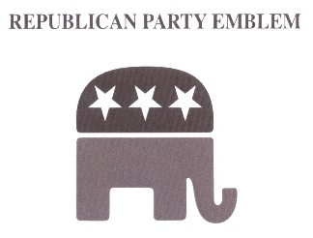
REPUBLICAN CANDIDATES
For U.S. SENATOR
ERIC SCHMITT, 937 BROWNELL AVE, GLENDALE, MO 63122

FOR STATE AUDITOR
SCOTT FITZPATRICK, 118 SKYLINE DR, CASSVILLE, MO 65625

FOR U.S. REPRESENTATIVE, DISTRICT 3
BLAINE LUETKEMEYER, 619 MAIN ST, ST. ELIZABETH, MO 65075

FOR U.S. REPRESENTATIVE, DISTRICT 4
MARK ALFORD, 13311 E 93RD ST, KANSAS CITY, MO 64138

FOR STATE SENATOR, DISTRICT 6
MIKE BERNSKOETTER, 5219 GLOVERS FORD RD, JEFFERSON CITY, MO 65101

FOR STATE REPRESENTATIVE, DISTRICT 123
LISA THOMAS, 15 BAY HILL COURT, LAKE OZARK, MO 65049

FOR STATE REPRESENTATIVE, DISTRICT 142
JEFF KNIGHT, 16931 HIGHWAY 32, LEBANON, MO 65536

FOR CIRCUIT JUDGE, CIRCUIT 26, DIVISION 2
KENNY HAYDEN, 19584 SOUTH MARVIN RD, BARNETT, MO 65011

ASSOCIATE CIRCUIT JUDGE, CIRCUIT 26, DIVISION 4
MICHAEL J. GILLEY, 55 ANTIQUE ROSE LN, CAMDENTON, MO 65020

ASSOCIATE CIRCUIT JUDGE, CIRCUIT 26, DIVISION 5
HEATHER MILLER, 126 W CROSS FOX TRL, CAMDENTON, MO 65020

PRESIDING COMMISSIONER,
IKE SKELTON, 6274 SHADOW CIRCLE, OSAGE BEACH, 65065

COUNTY CLERK,
ROWLAND TODD, PO BOX 1045, CAMDENTON, MO 65020

CIRCUIT CLERK,
KAYLA HENRY, 18941 STATE RD A, RICHLAND, MO 65556

RECORDER,
DONNIE SNELLING, 898 SWINGING BRIDGES RD, MONTREAL, MO 65591

PROSECUTING ATTORNEY,
RICHELLE CHRISTENSEN GROSVENOR, PO BOX 1711, FOUR SEASONS, MO. 65049

COUNTY AUDITOR,
JIMMY LAUGHLIN, 42 COUNTY ROUTE P, LEBANON, MO 65536

COUNTY COLLECTOR,
TERESA MURRAY, 663 STATE ROAD N, MACKS CREEK, MO 65786

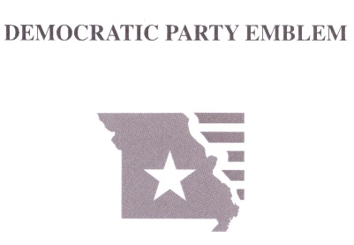
DEMOCRATIC CANDIDATES
FOR U.S. SENATOR
TRUDY BUSCH VALENTINE, 100 SUNNINGDALE DR, ST LOUIS, MO 63124

FOR STATE AUDITOR
ALAN GREEN, 12365 ROCKET DR, FLORISSANT, MO 63033

FOR U.S. REPRESENTATIVE, DISTRICT 3
BETHANY MANN, 8820 MADGE AVE, BRENTWOOD, MO 63144

FOR U.S. REPRESENTATIVE, DISTRICT 4
JACK TRUMAN, 747 NE FRANKLIN ST, LAMAR, MO 64759
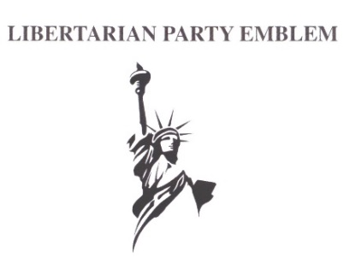
LIBERTARIAN CANDIDATES
FOR U.S. SENATE
JONATHAN DINE, 5119 NW 66TH TERR, KANSAS CITY, MO 64151

FOR STATE AUDITOR
JOHN A HARTWIG JR., 7707 DAVIS DR, ST LOUIS, MO 63105

FOR U.S. REPRESENTATIVE, DISTRICT 4
RANDY LANGKRAEHR, 103 N DEVASHER RD UNIT 10, WARRENSBURG, MO 64093
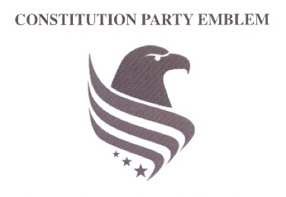
CONSTITUTIONAL CANDIDATES
FOR U.S. SENATOR
PAUL VENABLE, 1127 VAN BUREN ST, WARSAW, MO 65355

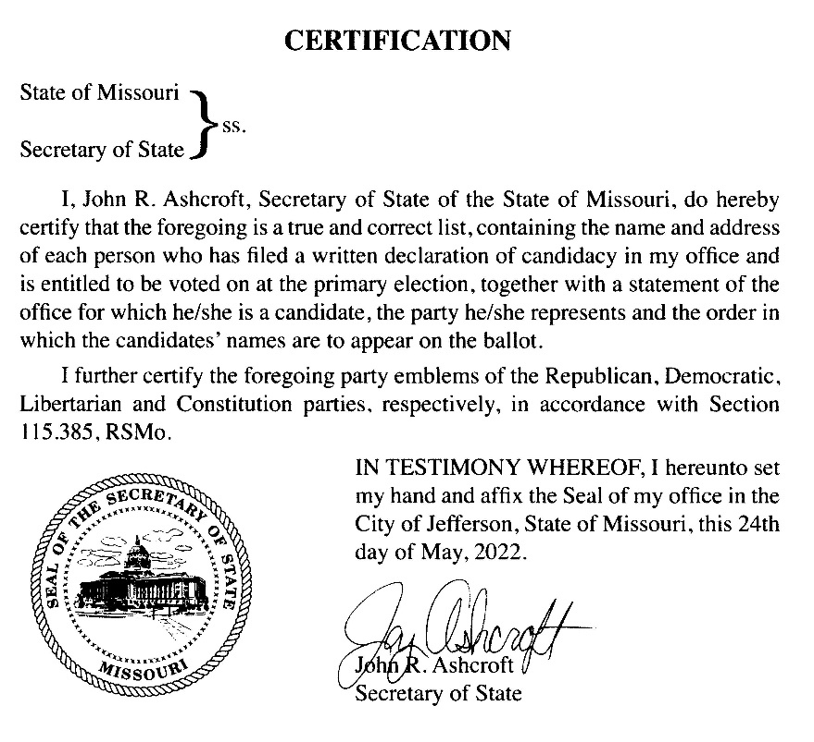

CAMDEN COUNTY CLERK CERTIFICATION

}}
State of Missouri
CAMDEN COUNTY SS.
Secretary of State

I, Rowland A. Todd, Camden County Clerk, within and for the county of Camden,
do hereby certify that the above and foregoing is a true and correct list of candidates
who have filed written declarations of candidacy in my office, and as certified to me
by John R. Ashcroft, Secretary of State, State of Missouri, of the candidates entitled to be
voted for at the Primary Election to be held August 2, 2022

IN TESTIMONY WHEREOF, I have hereunto set my
hand and affixed my seal. Done in my office this 2nd day
of June, 2022.

Rowland A. Todd
Camden County Clerk

